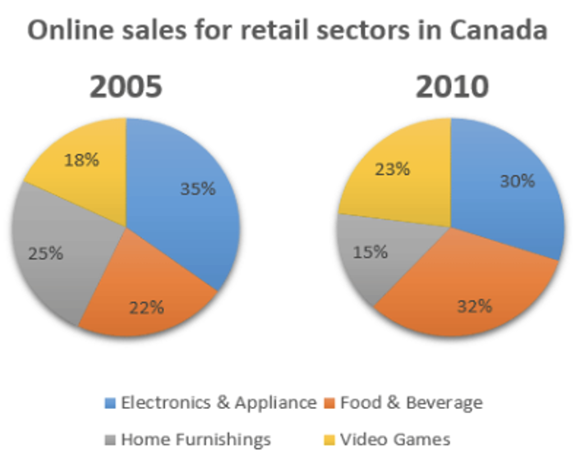
题目分析：这个图是饼状图，动态图，时间是2005和2010（过去时）
数据对象：the percentage of four categories of products traded online.
Overview：两个比较维度：
- 大小比较：在2010年，food & beverage最受欢迎；
- 趋势对比： electronics & appliances and home furnishings的比例下降，另外两种比例上升。
段落结构：2005年一段，2010年一段。
关键数据：图中的数据不是很多，都很重要，要全部提到。
- 2005年， electronics and appliances的比例最高，home furnishings 和food & drink其次，video games最小。
- 2010年，electronics & appliances的比例下降，成为第二。home furnishings的比例同样下降，是最小值。 food and beverage的比例上升，成为最大。 video games的比例同样上升，成为最大。

具体写法，可以参考下面的范文：

The pie charts give information about the online transactions of four categories of products in two years: 2005 and 2010.

虽然蓝灰最大，但是黄橙变大，橙色变成看最大
Overall, although electronics & appliances and home furnishings were less favored, the popularity of food & beverage and video games increased, with the former becoming the most popular category in 2010.

In 2005, the sales of electronics and appliances were the largest, accounting for 35%, followed by home furnishings (25%) and food & drink (22%). Video games were responsible for the smallest percentage, standing at only 18%.

In 2010, the proportion of electronics & appliances diminished to 30%, a figure that was the second-highest in this year. Similarly, the statistics for home furnishings dropped to 15%, which was the lowest. On the other hand, food and beverage were purchased much more, with the share expanding to 32%, the highest figurer among all sectors. Also, the sales of video games witnessed a modest climb, reaching 23%.

(~152 words)

